**Gannt Chart**

## Creating Gantt Chart

Using the Sample-superstore let,s plan to find the variation of quantities of different sub-category of products according to their ship mode over a range of time. To achieve this objective we follow the below steps.

### Step-1

Drag the dimension order date to the columns shelf and sub-category to the rows shelf. Next we add the order date to the filters shelf. Also right click on order date to convert it to exact date values. It is done as shown in the below diagram.

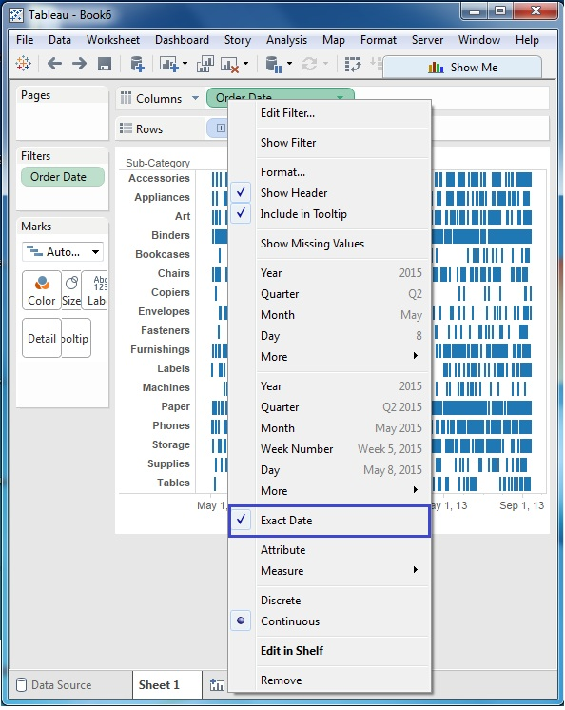

### Step-2

Next we edit the filter condition to select a range of dates. It is because we want individual date values and there is a very large number of dates in the data. The range is created as shown below.

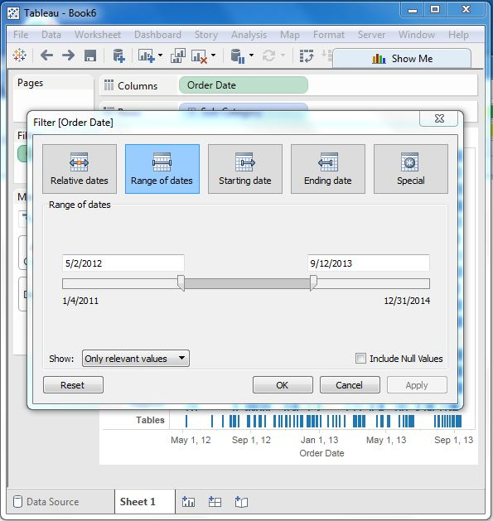

### Step-3

Next we drag the dimension ship mode to the color shelf and the measure Quantity to the size shelf under the Marks card. This produces the Gantt chart as shown below.

